MS SQL SERVER
Standard Operating Procedures
(SOP)
Restoration procedure and retention policy in SQL Server
Submitted to



BY



CIS, Wipro Limited

Document Details

Project Name | Innogy SE
Account | CIS
IT Component/Application Title | Restoration procedure and retention policy in SQL Server
Current Version | 1.5
List of Contributors | Pradipkumar Kansara, Kiran Bhalekar, Ayushi Gautam, Sivakumar Goud, Ayushi Srivastava
Customer Contact Information

Version History
(All revisions made to this document must be listed in chronological order. All revisions must be approved. Review and Approval can be done by an internal source or by the customer)
Version | Date of Revision | Description | Author | Reviewed By | Approved By
1.0 | 29-08-2015 | Initial Draft | Kiran Bhalekar | Pradipkumar Kansara | Mahesh Keshatwar
1.1 | 04-09-2015 | Document Completed | Kiran Bhalekar | Pradipkumar Kansara | Mahesh Keshatwar
1.2 | 21-08-2016 | Updated document to standard format | Kiran Bhalekar | Pradipkumar Kansara | Mahesh Keshatwar
1.3 | 17-05-2017 | Wipro and Innogy Logo changed | Sivakumar Goud | Pradipkumar Kansara | Mahesh Keshatwar
1.4 | 14-09-2017 | Updated document to Wipro Standard format with header and footer | Sivakumar Goud | Pradipkumar Kansara | Santosh Badiger
1.5 | 11-11-2018 | Updated the content | Ayushi Srivastava | Pradipkumar Kansara | Santosh Badiger

Document Distribution List
Sl. No. | Name and Company | Purpose
1 | RWEIT-SQLDBA | Document is useful for SQL server restoration policy and retention period in sql server.
2

TABLE OF CONTENT

1. Purpose 1
2. Scope 1
3. Restoring Complete Database Backups 1
3.1 Restoring A Complete Backup To The Same Database 1
3.2 Restoring A Complete Backup To A New Database On The Same Server 7
3.3 Restoring A Complete Backup To A New Server 10
4. Backup Retention 15
5. Reference 16

Purpose
This document is prepared for the Restoration procedure & retention policy of backup in SQL Server Database Administration Services at <Customer Name>.

Scope
This document is prepared for GSMC Wipro sustenance team and provides the concepts of Restoration procedure & Retention policy of backup for the administration of the SQL Server database at <Customer Name>.

Restoring Complete Database Backups
A complete database backup may be restored to the same or a new or different database on the same (or a different) server. The restore operation may be initiated either through either SQL Server Enterprise Manager or the Transact-SQL command window.
It is highly advisable to restore complete database backups at regular intervals, as this is the only means that is currently available to verify the “restorability” of an SQL Server backup.

3.1 Restoring a Complete Backup to the Same Database
Open SQL Server Enterprise Manager and connect to the server where the backup is to be restored.

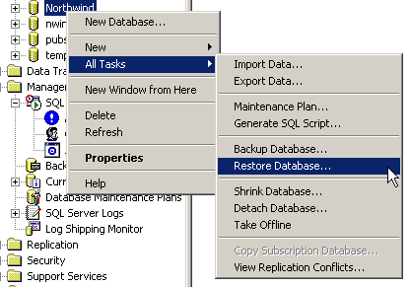

Restore database through Enterprise Manager

- Right-click the database and select All Tasks, then select Restore database The Restore Database dialog box is displayed.
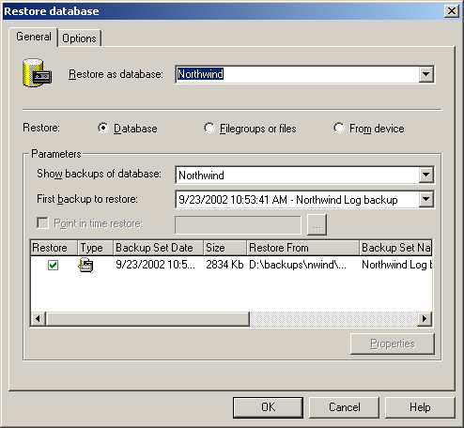
Restore Database dialog box

- From the list of databases, select the database for which the backup has to be restored.
A list of all backups performed for the selected database is displayed in the Parameters section of the Restore Database dialog box. This information is collected from the history tables in the MSDB database.
- From the list of backups, select the backup to restore, then click the Properties button to display the Backup Set Properties dialog box shown in Figure.
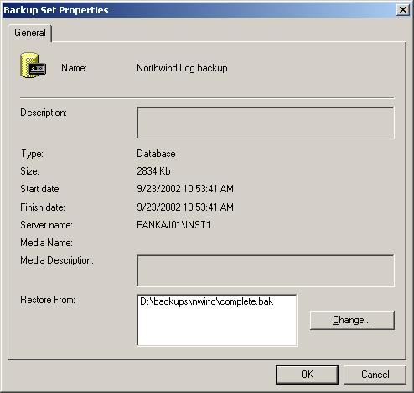
Backup Set Properties dialog box
The dialog box displays backup properties including backup type, size (in KB), start and finish dates, server name, and media description.
- In the Backup Set Properties dialog box, click OK.
- In the Restore Database dialog box click the Options tab.
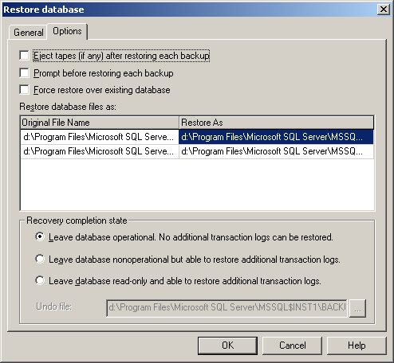
Restore Database Options
The Options tab in the Restore Database dialog box provides options to select the final restore state, change the file name, and set tape options for the restore operation.
- Select the appropriate settings in this dialog box.
Description of fields
Eject tapes after restoring each backup – ejects the tape when the restore operation completes if a tape restore is being performed.
Prompt before restoring each backup – displays a dialog box after each backup is restored successfully. This option may be used when restoring multiple backups.
Force restore over existing database – forces the files for the existing database to be initialized. This option should be used with caution as it erases the data that exists in the selected database before starting the restore operation.
Restore As – shows the original and target physical file names for the database that is being restored.
Recovery completion state – determines the final state of the restored database.
Undo file – a file required by SQL Server to track incomplete transactions if the backup is restored in standby state.
- To start the restore operation, click OK. The Restore Progress dialog box is displayed while the restore operation executes.
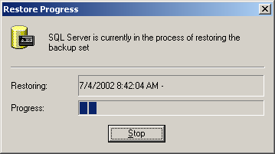
Restore Progress dialog box

- When the restore operation completes, the dialog box shown in Figure 20 is displayed. To close it, click OK.

Restore database complete confirmation

3.2 Restoring a Complete Backup to a New Database on the Same Server
A new database may be created while restoring a complete database backup. The new database may be created on the same server where the original database was located, or on a different server. In either case, there are several restrictions placed on the database if it is created in this manner:
- Physical file structure may not be modified while restoring
- Logical file names may not be changed
- Physical files created must be the same size as when the backup was performed
If you intend to create a new database, as part of the restore operation, on the same server where the original database still resides, follow this procedure.

To restore a complete backup to a new database on the same server
- Open SQL Server Enterprise Manager and connect to the server where the backup is to be restored.
- Right-click any database and select All Tasks, then select Restore Database to open the dialog box shown in Figure.
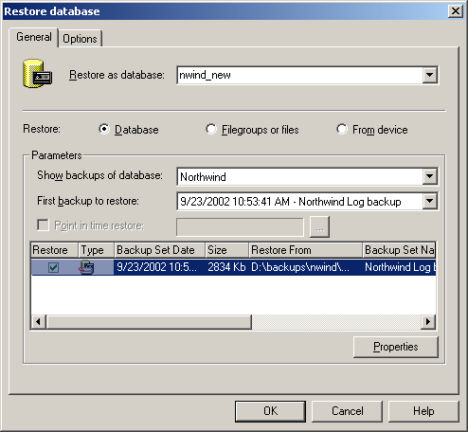
Figure: “Restore Database As” dialog box

- In the Restore as database: text box, enter the name of the new database that you wish to create.
- Under Parameters, select the database for which you intend to restore the backups (in the Show backups of database list box).
A list of backups for the database is displayed in window.
- Select the backup that you would like to restore and click Properties to verify the properties for that backup.
- Click the Options tab.
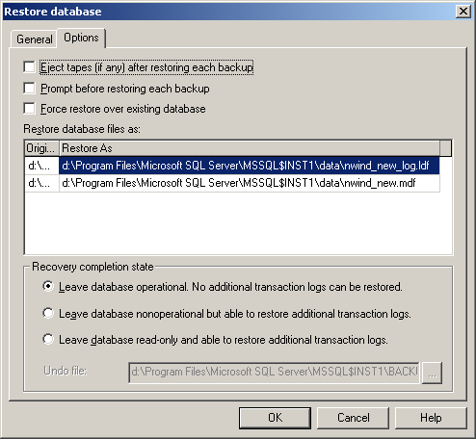
Figure: “Restore Database As” Options dialog box
- If necessary, modify the file name and location of the database files listed in the Restore As list. The first part of the file name is used as the logical name for the respective file.
- Select all the other options from this dialog box as necessary. For an explanation of these options.
- To start the restore operation, click OK. A progress dialog box is displayed and when the restore operation is finished, a confirmation dialog box is displayed. A new database called nwind_new is added to the Enterprise Manager window.
This functionality can also be accomplished by using Transact-SQL commands. Assuming that the database backup file name is c:\backups\northwind\nwind.bak, the following command will restore the database to nwind_new:

RESTORE DATABASE nwind_new FROM DISK = 'c:\backups\northwind\nwind.bak'
WITH
MOVE 'northwind' TO 'd:\Program Files\Microsoft SQL
Server\Data\nwind_new.mdf'
MOVE 'northwind_log' TO 'd:\Program Files\Microsoft SQL
Server\Data\nwind_new_log.ldf'

Check a backup file on disk
The following command will check the backup file and return a message of whether the file is valid or not. If it is not valid, this means the file is not going to be useable for a restore and a new backup should be taken. One thing to note is that if there are multiple backups in a file, this only checks the first file.
Restore verifyonly from disk FROM DISK = 'c:\backups\northwind\nwind.bak'
And
The RESTORE FILELISTONLY option allows you to see a list of the files that were backed up. So for example if you have a full backup you will see all of the data files (mdf) and the log file (ldf).

Restore filelistonly from disk FROM DISK = 'c:\backups\northwind\nwind.bak'

3.3 Restoring a Complete Backup to a New Server
SQL Server databases may be backed up on one server and restored to another server. If the target database does not exist on the second server, it may be created before the restore is initiated. However a new database can be created while restoring the backup.
If a new database is created while restoring the backup, all the restrictions mentioned in Restoring a Complete Backup to a New Database on the Same Server apply.
The steps in this section demonstrate one of the many ways that someone may use to restore the database onto a different server. Another means of achieving this same functionality would be to restore the backup history using the procedure explained in Adding Backup History from Backup Files to MSDB and then using the procedure listed in Restoring a Complete Backup to a New Database on the Same Server using the SQL Enterprise Manager GUI.
To restore a database backup to a different server to a new database
- Copy the database backup file to the target machine or share it on the network so that it is accessible from the server.
- Open Enterprise Manager and connect to the server to which the backup is to be restored.
- Right-click any database and select All Tasks, then select Restore Database to display the Restore Database dialog box.
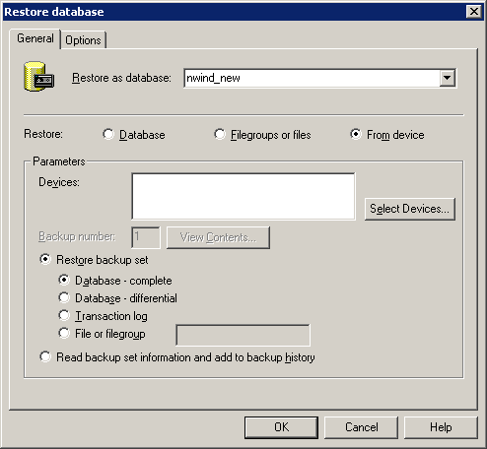
Figure: “Restore from device” dialog box

- Enter the name of the new database that the backup process will create and restore the backup to, in the Restore as database : list box.
- Select the from device radio button.
- Click the Select Devices... button.
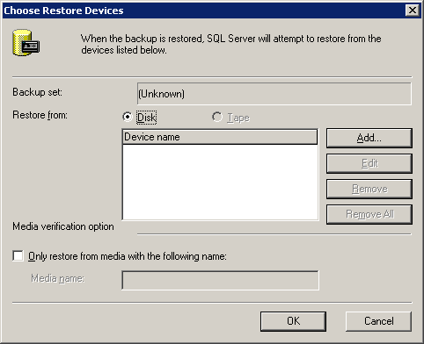
Figure: Choose Restore Devices dialog box

- In the Choose Restore Devices dialog box, select either the Disk or the Tape radio button.
In the dialog box, the Tape option is dimmed (unavailable) because the backup device does not have a tape drive configured. For the purposes of this example we will assume that we are restoring the backup from a disk device.
- Click the Add button to display the dialog box.
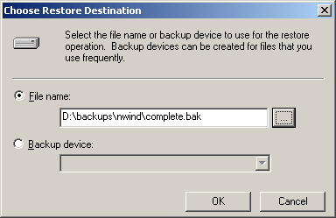
Figure: Choose Restore Destination dialog box

- Enter the file name of the backup file that is to be restored. If the file exists on a network share, provide the UNC share name in the File name text box.
Note It is recommended that the backup be copied to the server and a local path be used to restore the database.
- Click the OK button. The Choose Restore Device dialog box, is now updated with the selected file.
- Click the OK button to return to the Restore Database dialog box. The Devices list is now updated with the file selected in the previous step.
- Click the Options tab and select appropriate options for the restore operation. The file names of the physical files may be changed at this time. For more information on the fields in this dialog box, see steps 6 and 7 in restoring a Complete Backup to a New Database on the Same Server.
- Click OK in the Restore Database dialog box. This starts the restore process.
Progress and confirmation dialog boxes are displayed as SQL Server processes and completes the restore of the database.
- Click OK in the confirmation dialog box.
This restore operation may also be accomplished through Transact-SQL commands. The command would be similar to the one demonstrated in Restoring a Complete Backup to a New Database on the Same Server.

Backup Retention

Use the media retention option to provide a system-wide default for the length of time to retain each backup set. The media retention option helps protect backups from being overwritten until the specified number of days has elapsed. When you set media retention, you do not have to specify the length of time to retain system backups each time you perform a backup. The default is 0 days. If you use the backup medium before the set number of days has passed, Microsoft SQL Server issues a warning message. SQL Server does not issue a warning unless you change the default.

To set the backup retention duration
- In Object Explorer, right-click a server and select Properties.
- Click the Database settings node.
- Under Backup/Restore, in the Default backup media retention box, type or select a value from 0 through 365 to set the number of days the backup medium will be retained after a database or transaction log backup.
The default value is 0 days.

Reference
http://technet.microsoft.com/

